# **DistilBERT and ALBERT: A Comprehensive Research Analysis**

## **Abstract**

This research provides a comprehensive analysis of two prominent efficient transformer variants: DistilBERT and ALBERT. Both models address BERT's computational limitations through different optimization strategies. DistilBERT via knowledge distillation and ALBERT through parameter sharing and factorization. This analysis examines their architectures, performance characteristics, applications, and comparative advantages in modern natural language processing tasks.

## **1. Introduction and Background**

BERT revolutionized natural language processing by achieving state-of-the-art results across numerous benchmarks. However, BERT's computational requirements and large parameter count present significant challenges for deployment in resource-constrained environments, driving the development of more efficient alternatives that maintain competitive performance while reducing computational overhead.

DistilBERT and ALBERT represent two distinct approaches to creating lightweight transformer models. DistilBERT employs knowledge distillation techniques to create a smaller, faster version of BERT, while ALBERT introduces architectural innovations including parameter sharing and factorized embeddings to achieve efficiency gains. The significance of these models extends beyond academic research, enabling deployment of sophisticated language understanding capabilities in production environments where computational resources are limited.

This research examines both models comprehensively, providing insights into their architectural innovations, performance benchmarks, and practical implementation considerations.

## **2. DistilBERT: Knowledge Distillation Approach**

### **2.1 Architecture and Training Methodology**

DistilBERT has about half the total number of parameters of BERT base and retains 95% of BERT's performances on the language understanding benchmark GLUE. The model uses a similar general architecture as BERT, but with fewer encoder blocks (6 blocks, compared to 12 blocks of BERT-base). The token-type embeddings and pooler are removed, significantly reducing computational requirements while maintaining essential language understanding capabilities.

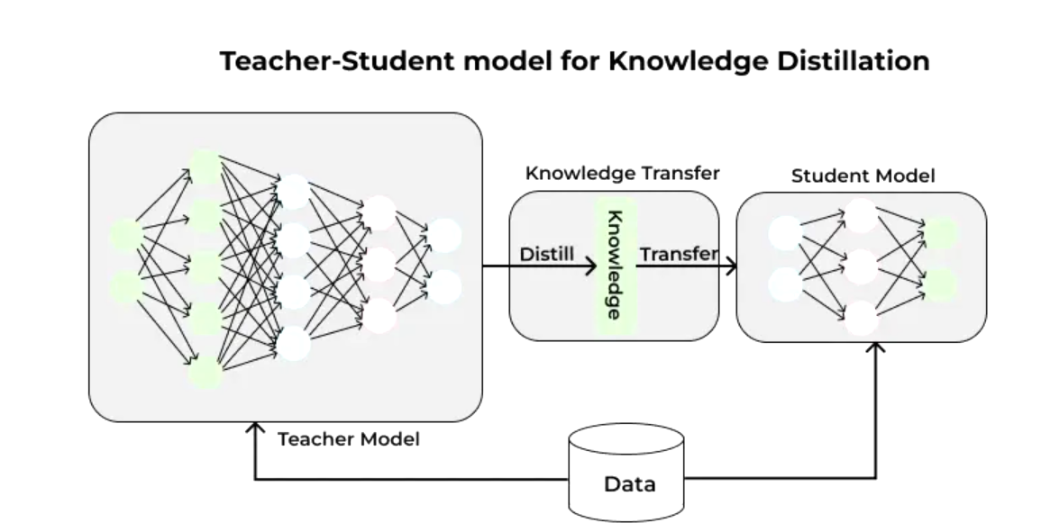

DistilBERT is pretrained by knowledge distillation through a triple loss objective: language modeling loss, distillation loss, and cosine-distance loss. The knowledge distillation process involves training DistilBERT to mimic BERT's behavior rather than learning from scratch, allowing the smaller model to leverage knowledge encoded in the larger BERT model.

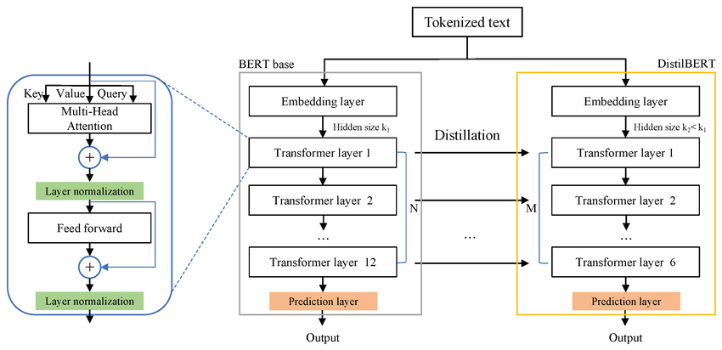

### **2.2 Performance Characteristics**

Recent comparative studies show varied performance across different tasks with the same hyperparameters: 98.30 for RoBERTa, 98.20 for XLNet, 97.40 for BERT, 97.20 for ALBERT, and 96.00 for DistilBERT on sentiment classification tasks. While DistilBERT achieves respectable performance, it typically ranks lower than other transformer variants in direct comparisons, trading some accuracy for significant efficiency gains.

## **3. ALBERT: Parameter Efficiency Through Innovation**

### **3.1 Architectural Innovations**

ALBERT introduces two primary innovations: factorized embedding parameterization and cross-layer parameter sharing. These modifications enable significant parameter reduction while maintaining or improving performance compared to BERT. ALBERT-large has about 18x fewer parameters compared to BERT-large, 18M versus 334M. ALBERT-xxlarge configuration with H = 4096 has 233M parameters, around 70% of BERT-large's parameters.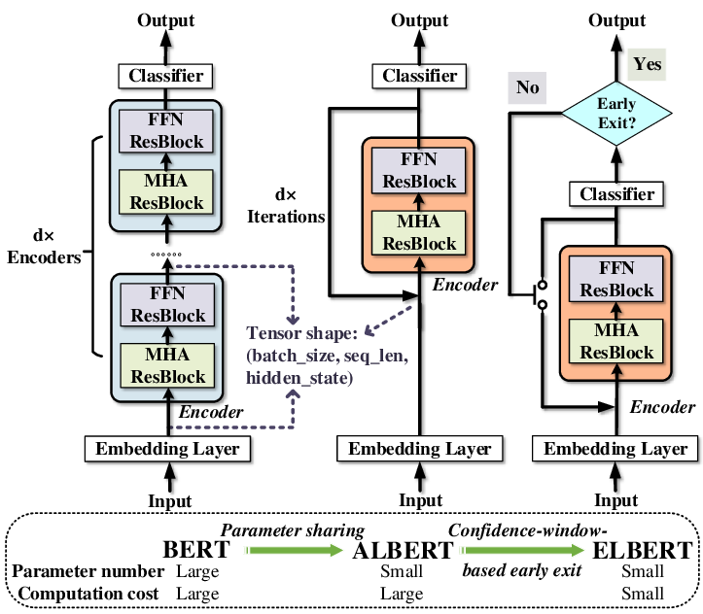

Cross-layer parameter sharing assumes that similar transformations can be applied across different layers, reducing total unique parameters while maintaining model expressiveness. The factorized embedding approach separates the embedding matrix into smaller matrices, achieving an 80% reduction in projection block parameters with minimal performance drop.

### **3.2 Superior Performance**

Albert outperforms all previous models including BERT, RoBERTa, DistilBERT, and XLNet. With only around 70% of BERT-large's parameters, ALBERT-xxlarge achieves significant improvements over BERT-large on development set scores: SQuAD v1.1 (+1.9%), SQuAD v2.0 (+3.1%), MNLI (+1.4%), SST-2 (+2.2%). ALBERT achieved an exact match of 86.85% and an F1 score of 89.91% on the SQuAD v2 dataset, demonstrating superior performance in both answerable and unanswerable question scenarios

## **4. Comparative Analysis and Applications**

### **4.1 Performance and Efficiency Comparison**

ALBERT large achieves comparable performance to BERT large and is 1.7x times faster due to massive parameter size compression. The performance gap between DistilBERT and ALBERT becomes more pronounced in complex language understanding tasks. While DistilBERT excels where speed and resource efficiency are paramount, ALBERT provides superior accuracy for performance-critical applications.

Different tasks reveal varying performance characteristics. ALBERT outperformed other models with 87.6% accuracy, 86.9% precision, 86.9% F1-score, and 174.5 run-time (s/epoch) in fake news detection tasks, demonstrating versatility across diverse NLP applications. The choice between models depends on specific application requirements, with DistilBERT favored for extremely resource-constrained environments and ALBERT preferred when optimal performance within reasonable computational bounds is required.

### **4.2 Practical Applications and Implementation**

Both DistilBERT and ALBERT have found widespread adoption across various domains. DistilBERT's lightweight nature makes it particularly suitable for mobile applications, edge computing, and real-time processing scenarios where latency is critical. The model's efficiency characteristics enable deployment in production environments that would be prohibitive for larger models like BERT-large or GPT variants.

ALBERT's superior performance while maintaining efficiency has made it popular in enterprise applications requiring high-quality language understanding with reasonable computational costs. The model has been successfully applied in sentiment analysis, question answering, text classification, named entity recognition, and document summarization tasks.

Current research trends focus on comparing several leading small language models including DistilBERT, ALBERT, TinyBERT, MiniLM, and newer entrants released in 2024–2025. The field continues to evolve with new compression techniques and architectural innovations building upon the foundations established by these models. Recent developments emphasize further parameter reduction, improved training techniques, and domain-specific optimizations.

## **5. Limitations, Future Directions, and Conclusions**

### **5.1 Limitations and Considerations**

While both models offer significant advantages, they have important limitations that must be considered in practical applications. DistilBERT's performance degradation in complex reasoning tasks can limit its applicability in sophisticated NLP applications that require deep language understanding. The knowledge distillation process, while effective, cannot fully capture all the nuanced representations learned by the teacher model, particularly in tasks requiring multi-step reasoning or complex inference.

ALBERT's parameter sharing strategy, while efficient, may constrain the model's ability to learn task-specific representations across different layers. This limitation can become apparent in tasks that benefit from layer-specific specialization. Additionally, despite parameter reduction, ALBERT's training time can be longer due to the shared parameters requiring more epochs to converge effectively.

The choice between these models requires careful consideration of multiple factors including accuracy thresholds, computational constraints, inference speed requirements, memory limitations, and specific deployment environment characteristics. Organizations must balance performance requirements against available computational resources when selecting between these efficient alternatives.

### **5.2 Future Directions and Research Trends**

The continued evolution of efficient transformer models suggests that principles pioneered by DistilBERT and ALBERT will significantly influence future architectures. Emerging techniques such as structured pruning, quantization-aware training, and neural architecture search are being combined with distillation and parameter sharing approaches to create even more efficient models.

Recent research directions include multi-teacher distillation, where multiple specialized models serve as teachers for different aspects of language understanding, and progressive knowledge distillation, which gradually reduces model size during training. Additionally, task-specific compression techniques are being developed to optimize models for particular applications rather than general-purpose language understanding.

The integration of these models with hardware-specific optimizations, such as mobile processors and edge computing devices, represents another important research direction. As deployment environments become increasingly diverse, adaptive model compression techniques that can adjust efficiency based on available resources are gaining attention.

## **6. Conclusions**

DistilBERT and ALBERT represent two highly successful approaches to addressing the computational challenges of large language models, each offering distinct advantages for different use cases. DistilBERT's knowledge distillation approach provides a straightforward and effective path to model compression, making sophisticated language understanding accessible in resource-constrained environments. The model's ability to retain 95% of BERT's performance while using only half the parameters demonstrates the effectiveness of teacher-student learning paradigms in neural network compression.

ALBERT's architectural innovations demonstrate how clever design principles can achieve both efficiency and performance improvements simultaneously. Through parameter sharing and factorized embeddings, ALBERT not only reduces computational requirements but often exceeds the performance of its larger counterparts. This achievement challenges the conventional wisdom that model performance necessarily correlates with parameter count.

The success of both models demonstrates that the pursuit of ever-larger models is not the only path to improved NLP capabilities. Instead, thoughtful architectural design, innovative training methodologies, and strategic optimization can achieve remarkable results while remaining practical for real-world deployment. Their influence extends beyond their specific implementations, having established fundamental paradigms for creating practical, deployable language models that effectively balance performance with computational responsibility.

As the field progresses toward more sustainable AI practices, the efficiency-focused design philosophies pioneered by DistilBERT and ALBERT remain highly relevant and influential. These models have proven that high-quality natural language processing can be achieved within reasonable computational bounds, making advanced AI capabilities accessible to a broader range of applications and organizations. The principles established by these models continue to guide the development of future generations of efficient language models, ensuring their lasting impact on the field of natural language processing.

## **References**

[1] Sanh, V., Debut, L., Chaumond, J., & Wolf, T. (2019). DistilBERT, a distilled version of BERT: smaller, faster, cheaper and lighter. *arXiv preprint arXiv:1910.01108*.

[2] Lan, Z., Chen, M., Goodman, S., Gimpel, K., Sharma, P., & Soricut, R. (2019). ALBERT: A Lite BERT for Self-supervised Learning of Language Representations. *arXiv preprint arXiv:1909.11942*.

[3] Devlin, J., Chang, M. W., Lee, K., & Toutanova, K. (2018). BERT: Pre-training of Deep Bidirectional Transformers for Language Understanding. *arXiv preprint arXiv:1810.04805*.

[4] Hinton, G., Vinyals, O., & Dean, J. (2015). Distilling the knowledge in a neural network. *arXiv preprint arXiv:1503.02531*.

[5] GeeksforGeeks. (2024). DistilBERT in Natural Language Processing. Retrieved from <https://www.geeksforgeeks.org/nlp/distilbert-in-natural-language-processing/>

[6] Quantpedia. (2024). Top Models for Natural Language Understanding (NLU) Usage. Retrieved from<https://quantpedia.com/top-models-for-natural-language-understanding-nlu-usage/>